

Dear New Patient:

Thank you and welcome to Cincinnati Urogynecology Associates, the offices of Dr. Rachel Pauls,
Dr. Catrina Crisp, Dr. Jenn Yeung, Dr. Kelsey Lewis and Dr. Anna Zdroik

We look forward to meeting you on @ in:
________ Good Samaritan Medical Office Building
________ West Chester
________ TriHealth Kenwood
________ Anderson Location
________ Western Ridge

To help assess your individual needs, enclosed are the following forms for your completion:

- Initial Office Visit
- Involvement in Care
- Questionnaire

Please complete the above forms to the best of your abilities and bring them to your scheduled office visit. Do not hesitate to call our office with any questions or if you need additional information. Please arrive 15 minutes early for your first appointment. You will also need to bring your insurance card, co-pay, and list of medications to your visit. We accept checks, debit cards, Visa, MasterCard and Discover for payment of your co-pay.

Please check with your insurance company prior to your appointment to assure that our physicians are providers on your plan.

Sincerely,

Cincinnati Urogynecology Associates

West Chester
8020 Liberty Way
2nd floor
West Chester, OH 45069
513-463-4300

Good Samaritan Women’s Center
TriHealth Kenwood
8240 Northcreek Dr.
Suite 4100
Cincinnati, OH 45236
513-463-4300

Western Ridge
Anderson
7777 Beechmont Ave.
Suite 100
Cincinnati, OH 45255
513-463-4300

3219 Clifton Ave.
Suite 100
6949 Good Samaritan Dr. 2nd Floor

Cincinnati, OH 45220 Cincinnati, OH 45247
513-463-4300 513-463-4300



Typical Initial Office Visit

As a new patient to Cincinnati Urogynecology Associates, you will receive a packet of information to complete prior to your first visit. This packet contains directions to our office locations, registration forms, medical history forms, and symptom diaries. It is important for you to spend time before your appointment completing these forms. Having the information completed prior to your appointment will allow more interactive time and care planning with the staff and physicians.

The following process will occur on your first visit. The visit will take approximately 1-1 ½ hours. It will begin with a member of our clinical team taking and recording your vital signs while the physician reviews the packet of information that you have completed. One of our physicians will meet with you to discuss your medical history, reason for your visit, significant problems or symptoms that you are experiencing and how these problems are affecting your quality of life. The doctor will also review your symptom diaries.

If you are visiting for Incontinence, Prolapse, or Bladder Issues:

After the initial interview with the physician, they will ask you to prepare for the physical exam. You will be given time to use the restroom, which is located in the exam room, and to undress for the exam. This exam is similar to those given at your gynecology office; however, our physician is a specialist who is looking for physical changes that may be causing your symptoms.

Typically, a bladder test is done to understand the scope and origins of your symptoms. The bladder test generally takes about 15-20 minutes and will give the physician measurements of your bladder function. Once the test is completed, the doctor will review the findings with you. A course of treatment will then be discussed which could include pelvic floor physical therapy, medication, further testing, and/or surgical intervention. There will be time for you to ask questions of the physician.

Cincinnati Urogynecology Associates is affiliated with TriHealth, a teaching institution.

Drs. Rachel Pauls, Catrina Crisp, Jennifer Yeung, Kelsey Lewis and Anna Zdroik are all members of the faculty for TriHealth’s OB-GYN residency.

Our physicians also directly supervise the
Urogynecology Fellowship Program for TriHealth.
Participating doctors, called Fellows, who are selected for this fellowship program, are graduated, board-eligible or board-certified OB-GYN physicians. They are choosing to advance their training in the specialty of Urogynecology.

Dr. Rachel Pauls, Dr. Catrina Crisp, Dr. Jennifer Yeung
Dr. Kelsey Lewis and Dr. Anna Zdroik are committed to training the next generation of physicians in providing the same high quality care that they currently provide to their own patients.

As a result of this affiliation and faculty status, you will have residents and fellows involved in your care.

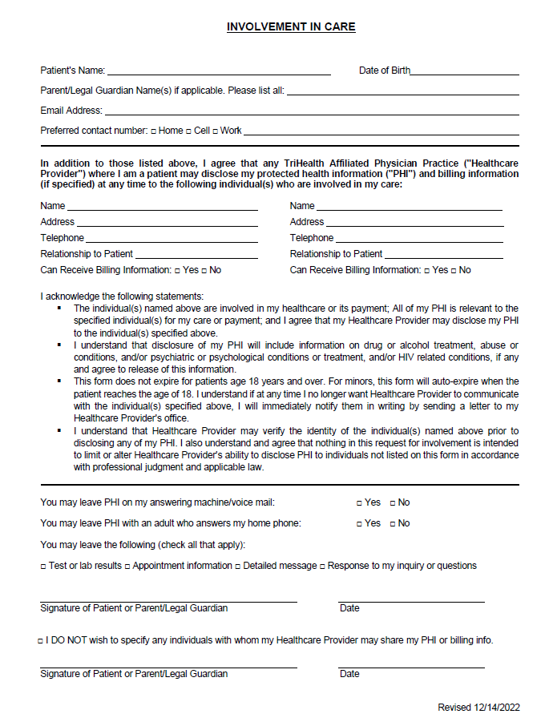

LAST NAME: ___________________________________ FIRST NAME: ___________________________________ AGE: _________________

Date of appointment: _________________________ Date of Birth: ____________________________ Race: ____________________

Referring physician: _____________________________ Other Referral: __________________________________________

Chief Complaint (why you came to see the doctor): ________________________________________________________

___________________________________________________________________________________________________________________

___________________________________________________________________________________________________________________

PELVIC ORGAN SYMPTOMS:

BLADDER CONTROL PROBLEMS
Do you have problems with accidental loss of urine or urinary urgency/frequency? Y N
IF YOU ANSWERED YES, CONTINUE. IF NO, SKIP TO NEXT SECTION.
How many months or years have you had bladder problems? ____________Months _______________Years
Do you use pads to absorb lost urine? Y N If yes, how many pads do you wear in a day: __________
About how many trips do you make to the bathroom during the day? _____________
About how many times do you wake at night to go to the bathroom? _____________
Do you ever wet the bed while asleep? Y N
Are there times when you cannot make it to the bathroom in time? Y N
Does the sound, sight or feel of running water cause you to lose urine? Y N

Which best describes urine loss: (check all that apply)
□ I lose urine during coughing, sneezing, running, or lifting
□ I lose urine with changes in posture, standing, or walking
□ I lose urine continuously or without awareness such that I am constantly wet
□ I have sudden, urgent needs without the ability to make

Have you seen a physician for complaints of urine loss? Y N If yes, who? _________________________
Have you taken medication to prevent urine loss? Y N
If yes, what meds? ________________________________________
How many glasses of liquid do you consume daily? ____________________
How many drinks containing caffeine (coffee, tea, soda) do you consume daily? ________________

BLADDER EMPTYING PROBLEMS
Do you have problems with urinating or emptying your bladder completely? Y N
IF YOU ANSWERE YES, CONTINUE. IF NO, SKIP TO NEXT SECTION.
How long have you had bladder emptying problems? ________months _________years
Do you notice any dribbling of urine when you stand after passing urine? Y N
Do you usually have difficulty starting your urine stream? Y N
Do you have to assume abnormal positions to urinate? Y N
Do you have to strain to empty your bladder? Y N

Is your urine flow: Strong Weak Dribbling Intermittent

Do you feel as if your bladder is empty after passing urine? Y N

Page 1 of 4

Name: ___________________
DOB: ___________________

PROLAPSE/VAGINAL SUPPORT PROBLEMS
Do you have a feeling of fullness or pressure, bulge or protrusion of any vaginal tissue? Y N
IF YOU ANSWERED YES, CONTINUE. IF NO, SKIP TO NEXT SECTION.
Do you notice a bulge? Y N
How long have you had a protrusion or bulge? ___________months __________years
Are your symptoms worse at the end of the day or after standing for prolonged periods? Y N
Do you push the protrusion back to help with a bowel movement or to empty your bladder? Y N
Have you every used a pessary (a plastic support device) for this problem? Y N

BOWEL SYMPTOMS
Do you have problems with your bowels (bowel incontinence or difficulty emptying your bowels)? Y N
IF YOU ANSWERED YES, CONTINUE. IF NO, SKIP TO NEXT SECTION.
How long have you had bowel symptoms? _____________months ___________years
Do you have accidental loss of solid stool? Y N
Do you have accidental loss of liquid stool? Y N
Do you have accidental loss of gas? Y N
How long have you had accidental loss of stool or gas? __________months ___________years
How many episodes per week? ___________
Do you wear protective pads for this problem? Y N If yes, how many pads each day? ________
Do you have constipation? Y N Do you have diarrhea? Y N Problems with bloating? Y N
Do you have a frequent desire to have a bowel movement? Y N
Do you feel that your bowels are never completely empty? Y N
Do you ever place your fingers in your vagina or between the vagina and rectum to help with a bowel movement? Y N

SEXUAL HISTORY
Are you sexually active? Y N
If not sexually active, are barriers to sexual activity due to:
Prolapse (vaginal bulging) Y N
Incontinence Y N
Pain Y N

PELVIC PAIN
Do you have pain in your pelvic area? Y N
IF YOU ANSWERED YES, CONTINUE. IF NO, SKIP TO NEXT SECTION.
Where is your pain? □pelvic area □vagina □rectum □lower abdomen
How long have you had pelvic pain? _________months _________years
Is your pain relieved by bladder emptying? Y N
Do you have pain with urination? Y N
Are there any other measures that relieve pain? Y N If yes, what are they? _______________________________________
Do you see a pain specialist? Y N If yes, who? ______________________________________________

GYN HISTORY

Number of pregnancies _____________ Number of vaginal deliveries _____________ Number of c/sections ______________

Any complications such as: Lacerations Forceps Vacuum Episiotomy Weight of largest baby _____________

Provide one of the following: Last Menstrual Period _______________ OR Age at Menopause ________________

Date of last PAP smear test: _____________________ Was it normal? Y N
Date of last Mammogram _____________________ Was it normal? Y N
Do you have a history of sexually transmitted disease(s)? Y N If yes, type? _______________________________

Page 2 of 4
Name: ___________________
DOB: ___________________

MEDICAL HISTORY (Check all that apply)
______ Asthma ______ Diabetes ______ GI problems
______ Glaucoma ______ Stroke ______ Ulcers
______ Arthritis ______ High Blood Pressure ______ COPD
______ Bladder Infections ______ Blood clots ______ Fibromyalgia
______ Kidney Stones ______ Seizures/Convulsions ______ Liver Disease
______ Migraines ______ Depression/Anxiety ______ Thyroid Disease
______ Pneumonia ______ Tuberculosis (Tb) ______ Hepatitis A / B / C
______ Sleep Apnea ______ Bleeding Disorder

______ Heart Problems, please specify ___________________________________________________________________________

Cardiologist Name:_____________________________________________________________________________________

______ Cancer, please specify ____________________________________________________________________________________

______ Other ______________________________________________________________________________________________________

Do you see any other specialists? Please provide name and specialty____________________________________________________

SURGICAL HISTORY

Hysterectomy Date: _______________ Reason: ____ Prolapse ____ Fibroids ____ Bleeding ____ Endometriosis
Incision: ____Vaginal ____ Abdominal Ovaries removed? Y N

Bladder Repair Date: _______________ Reason: ____ Prolapse ____ Leakage
Incision: ____Vaginal ____ Abdominal

Result of surgery was: ____ Helped temporarily for _____mos/yrs ____ No Difference ____Made it worse

List all other surgeries:

___________________________ Date: ______________ _____________________________ Date: __________

___________________________ Date: ______________ _____________________________ Date: __________

___________________________ Date: ______________ _____________________________ Date: __________

DRUG ALLERGIES

 No Known Allergies

NAME REACTION NAME REACTION

________________ ______________________________ _______________________________________________

___________________________________________________________ __________________________________________________________________

___________________________________________________________ __________________________________________________________________

___________________________________________________________ __________________________________________________________________

___________________________________________________________ __________________________________________________________________

Page 3 of 4
Name: ___________________
DOB: ___________________
CURRENT MEDICATIONS (PRESCRIPTION AND OVER THE COUNTER)

Name Dose Purpose/Indication

_______________________________ ___________________________________ ___________________________________

_______________________________ ___________________________________ ___________________________________

_______________________________ ___________________________________ ___________________________________

_______________________________ ___________________________________ ___________________________________

_______________________________ ___________________________________ ___________________________________

_______________________________ ___________________________________ ___________________________________

□ If more space is needed, please attach a complete list of medications.

SOCIAL HISTORY
Marital Status  Single  Married  Divorced  Widowed  Separated
Alcohol use  Never  Rarely  Occasionally  Daily
Tobacco use  Never  Current ____packs/day for ____ years  Quit If so, when?___________ How long did you smoke? ______
Drug use  Never  Recreational  Daily Type:______________________________________
Occupation _________________________________________________________________________________________________
Does your occupation require heavy lifting? (> 25lbs) Y N

FAMILY HISTORY Check all that apply and indicate relationship of relative

 Cancer (specify site)_______________________________  Bleeding disorder ____________________________
 Heart disease ____________________________________  Diabetes ___________________________________
 Hypertension ____________________________________  Stroke _____________________________________
 Reactions to Anesthesia ____________________________  Other ______________________________________

Review of Systems Circle all that apply

Fever
Chills
Weight Loss
Fatigue
Sweating
Weakness
Rash
Itching
Headaches
Hearing loss
Ring of the ears
Ear pain
Ear discharge
Nosebleeds
Congestion
Noisy breathing
Sore throats
Blurred vision
Double vision
Light sensitivity
Eye pain
Eye discharge
Eye redness
Chest pain
Palpitations
Difficulty breathing
Leg pain
Leg swelling
Cough
Coughing up blood
Productive cough
Short of breath
Wheezing
Heart burn
Nausea
Vomiting
Abdominal pain
Diarrhea
Constipation
Blood in stool
Urgency
Frequency
Blood in urine
Flank pain
Muscle pain
Neck pain
Back pain
Joint pain
Falls
Easily bruises / bleed
Environmental allergies
Excessive thirst
Dizziness
Tingling
Tremor
Sensory change
Speech change
Seizures
Loss of consciousness
Depression
Suicidal issues
Substance abuse
Hallucinations
Anxiety
Insomnia
Memory loss

Other symptoms _____________________________________________________________________________________________

____________________________________________________ _____________________________
Patient or Guardian’s Signature Date
Page 4 of 4

Date:______________________

Name:______________________________________________ Date of Birth:________________________

This survey asks for your views about your health. This information will help you keep track of how you feel and how well you are able to do your daily activities. Please answer every question by selecting the answer as indicated. If you are unsure about how to answer a question, please give the best answer you can.

In general, would you say your health is: Excellent Very good Good Fair Poor

The following questions are about activities you might do during a typical day. Does your health bow limit you in these activities? If so, how much?

Moderate activities such as moving a table, pushing a vacuum cleaner, bowling, or playing golf.

Yes, limited a lot Yes, limited a little No, no limits at all

Climbing several flights of stairs

Yes, limited a lot Yes, limited a little No, no limits at all

During the past 4 weeks, have you had any of the following problems with your work or daily activities as a result of your physical health?

Accomplished less than you would like Yes No
Were limited in the kind of work or other activities Yes No

During the past 4 weeks, have you had any of the following problems with your work or daily activities as a result of any emotional problems (such as feeling depressed or having anxiety)

Accomplished less than you would like Yes No
Didn’t do work or other activities as careful as usual Yes No

During the past 4 weeks, how much did pain interfere with your normal work (including both work, outside the home, and house work) Not at all A little bit Moderately Quite a bit Extremely

Continue

These questions are about how you feel and how things have been with you during the past 4 weeks. For each question, please give the one answer that comes closest to the way you have been feeling.
How much of the time during the past 4 weeks….

All of the time | Most of the time | A good bit of the time | Some of the time | A little of the time | None of the time

Have you felt calm and peaceful?

Did you have a lot of energy?

Have you felt down- hearted and blue?

During the past 4 weeks, how much of the time has your physical health or emotional problems interfered with your social activities (like visiting friends, relatives, etc…)?

All of the time Most of the time Some of the time A little of the time None of the time

Your Bladder Diary
This Diary will help your health care tem.
Bladder Diaries show the cause of bladder control roble. The “sample line will show you how to use the diary.

Time | Drinks |  | Urine |  | Accidents
 | What  Kind? | How  Much? | How Many Times? | How much?  (Circle one) | Accidental  Leaks  (Circle one) | Did you Feel a strong urge to go?  (Circle one) | What were you doing at the time of the leak?
Sample | Coffee | 2 cups | 1 | Sm Med Lg | Sm Med Lg | Yes No | Running
6-7 a.m. |  |  |  | Sm Med Lg | Sm Med Lg | Yes No
7-8 a.m. |  |  |  | Sm Med Lg | Sm Med Lg | Yes No
8-9 a.m. |  |  |  | Sm Med Lg | Sm Med Lg | Yes No
9-10 a.m. |  |  |  | Sm Med Lg | Sm Med Lg | Yes No
10-11 a.m. |  |  |  | Sm Med Lg | Sm Med Lg | Yes No
11-12 a.m. |  |  |  | Sm Med Lg | Sm Med Lg | Yes No
12-1 p.m. |  |  |  | Sm Med Lg | Sm Med Lg | Yes No
1-2 p.m. |  |  |  | Sm Med Lg | Sm Med Lg | Yes No
2-3 p.m. |  |  |  | Sm Med Lg | Sm Med Lg | Yes No
3-4 p.m. |  |  |  | Sm Med Lg | Sm Med Lg | Yes No
4-5 p.m. |  |  |  | Sm Med Lg | Sm Med Lg | Yes No
5-6 p.m. |  |  |  | Sm Med Lg | Sm Med Lg | Yes No
6-7 p.m. |  |  |  | Sm Med Lg | Sm Med Lg | Yes No
7-8 p.m. |  |  |  | Sm Med Lg | Sm Med Lg | Yes No
8-9 p.m. |  |  |  | Sm Med Lg | Sm Med Lg | Yes No
9-10 p.m. |  |  |  | Sm Med Lg | Sm Med Lg | Yes No
10-11 p.m. |  |  |  | Sm Med Lg | Sm Med Lg | Yes No
11-12 p.m. |  |  |  | Sm Med Lg | Sm Med Lg | Yes No
12-1 a.m. |  |  |  | Sm Med Lg | Sm Med Lg | Yes No
1-2 a.m. |  |  |  | Sm Med Lg | Sm Med Lg | Yes No
2-3 a.m. |  |  |  | Sm Med Lg | Sm Med Lg | Yes No
3-4 a.m. |  |  |  | Sm Med Lg | Sm Med Lg | Yes No
4-5 a.m. |  |  |  | Sm Med Lg | Sm Med Lg | Yes No
5-6 a.m. |  |  |  | Sm Med Lg | Sm Med Lg | Yes No

I used _____ pads. I used _____ diapers today. (Write number)

Questions to ask my health care team: __________________________________________________________________________________________ ______________________________________________________________________________________________________________________________________________________________________________________________________________________________________________________________________________

